Stephan de Beer

CSC 2463

Dr. Jesse Allison

05/11/2022

**Final Project Documentation**

This project is a 2D platformer that you control with Joystick on Arduino. There is a Seven segment display that win show the players current life count as well a potentiometer that changes the background color. Once started you can jump from platform to platform as a Viking. The goal of the game is to grab the meat and take it to the campfire so you can eat(win). You get 5 life’s and if you lose them all you can restart (as prompted) by hitting R on your keyboard. You can double jump if you start jumping from a platform (aka not in air already). There is music playing in the background, sometimes doesn’t start right away so it is forced to start on your first jump. All the art besides player sprite sheet was made by me.

Video: <https://youtu.be/W9X3bnHIwVg>

The project consists of 2 main parts, the Arduino circuit and the software side on computer (works for Windows, Mac and Linux). Fair waring if you attempt to recreate this in Linux DO NOT USE AN UBUNTU DISTRO. This set up requires NodeJS/node http-server, ubuntu currently won’t let you run anything above v10.x for node and for node to run you need at least LTS which is currently 16.x. Now that we have dealt with the one and only issue for running this on a non-windows OS we can continue. The code(both Arduino and js), art as well as the windows version of serial communication can be found at this link

<https://github.com/StephandeBeer/pdmSpring2022/tree/main/Final>

It would be best to just pull the whole folder.

The game was made using P5, P5.Play for visual and physics side. Music was made with Tone.js and the Arduino side was coded in Arduino (big surprise there).

Only modifications needed to run this is to change the Port string in the Final.js where all the other declarations are.

**Wiring**

It is a bit complicated; it needs a tiny amount of cable management to avoid becoming a jumbled mess/spaghetti monster. The circuit is flexible to a large degree with minor code changes but if you want plug and play just follow the diagram. 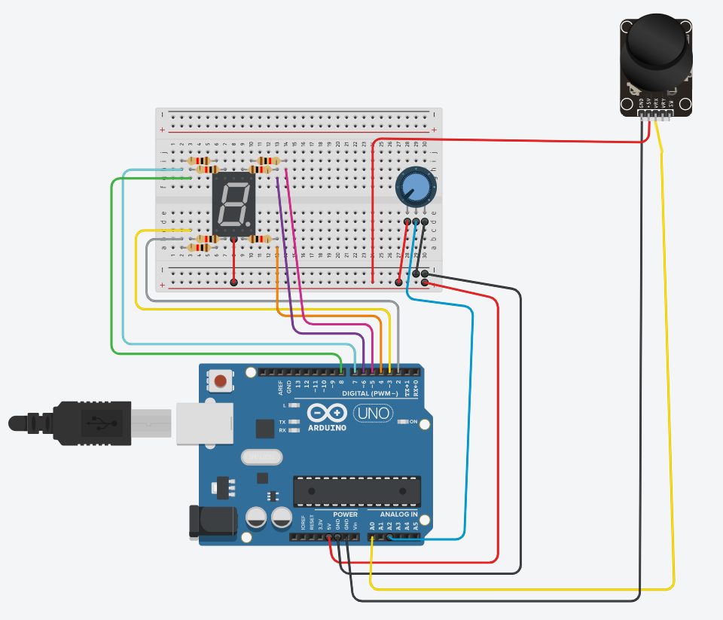

**Future Development**

I would definitely expand the level/ make more of them. I could make a main menu. I could add sounds for picking up the meat, death, victory and maybe jumping. I would probably change the sound pattern, I’m happy with the synth just not so much with the pattern I made. Adding a second player should also be easy enough to implement.